**Project Development Phase Works Done on Each Sprints**

|  |  |
| --- | --- |
| Date | 18-10-2022 |
| Team ID | PNT2022TMID15450 |
| Project Name | Inventory Management System for  Retailers |

# **Sprint split-ups**

1. Sprint 1 – Backend

2. Sprint 2 – Frontend

3. Sprint 3 – IBM Cloud Integration + Integration of SendGrid

4. Sprint 4 – Deploying the application using Docker and Kubernetes

## **Sprint 1 – Backend:**

All the routes to each page and APIs are created. Example, (For Products page)

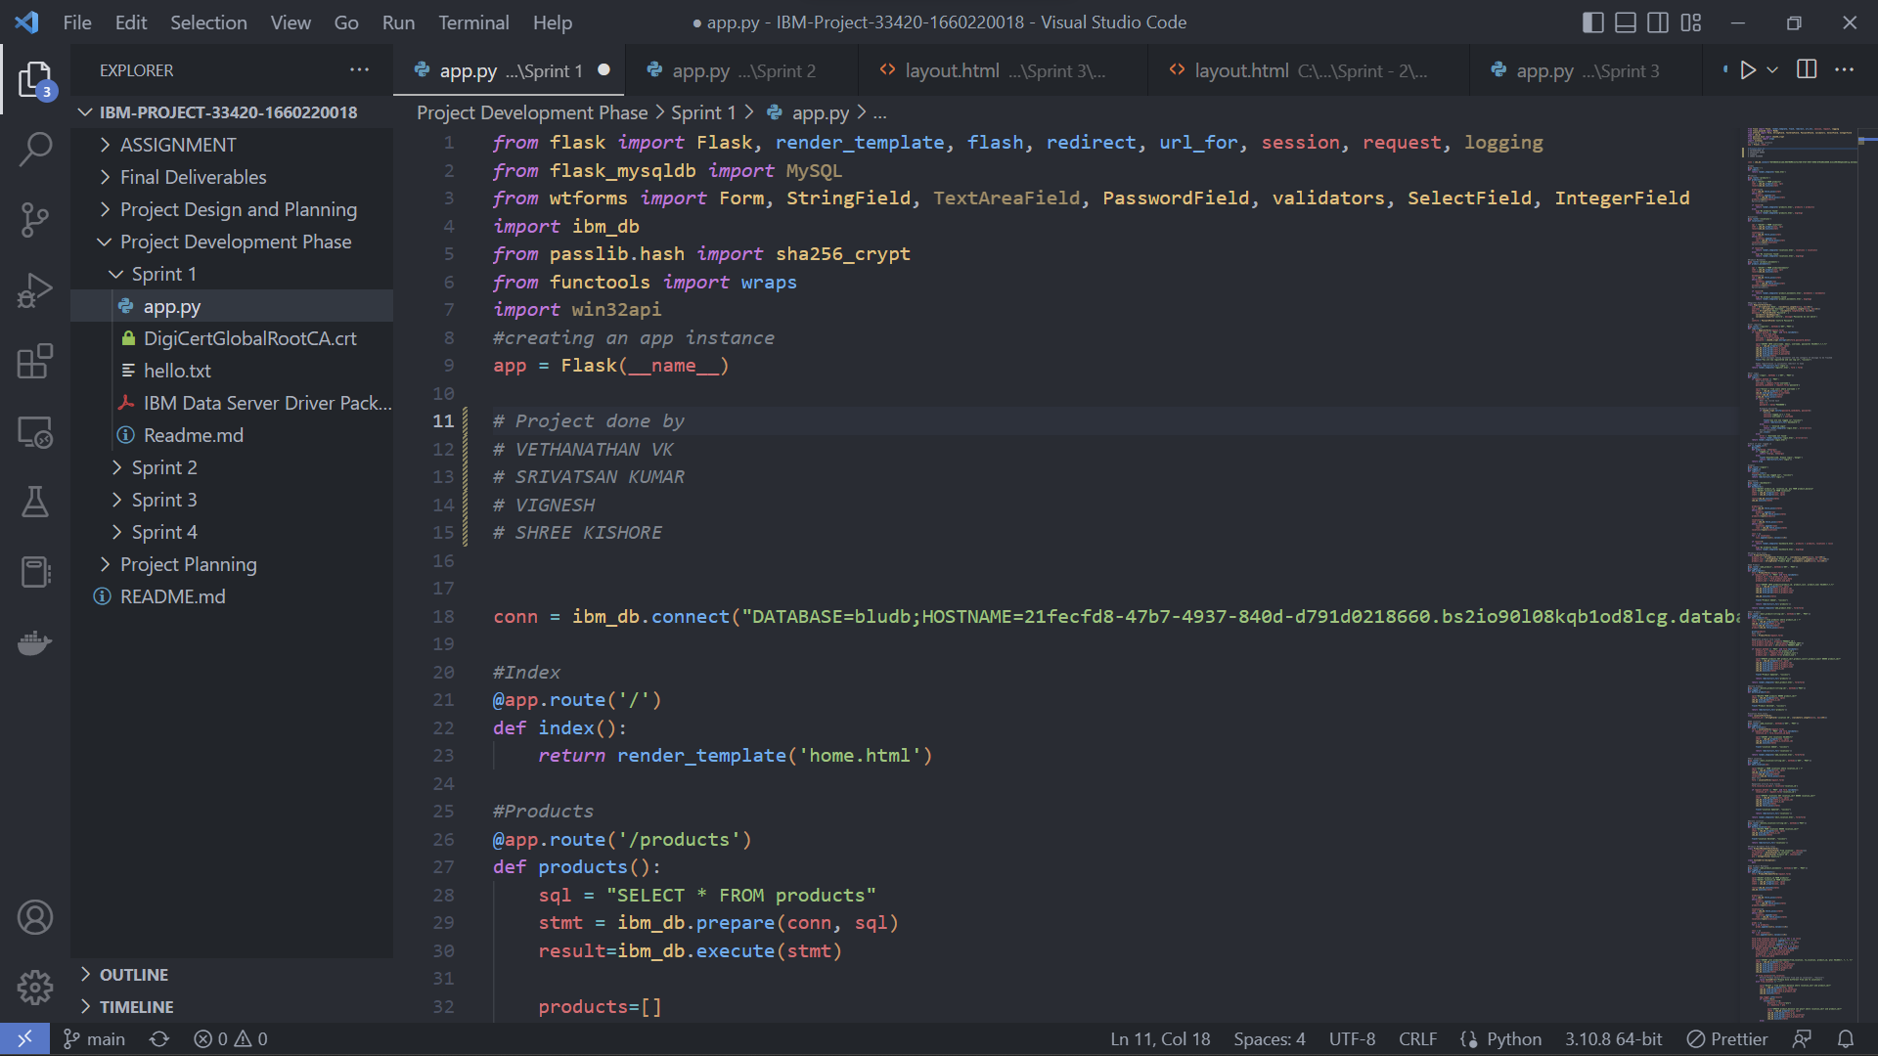

## **Sprint 2 – Frontend:**

The frontend is written using HTML, CSS (using Bootstrap) and JavaScript for all the pages to which the routes created in Sprint 1. For Example, (The Hierarchy of different pages and the code for login page)

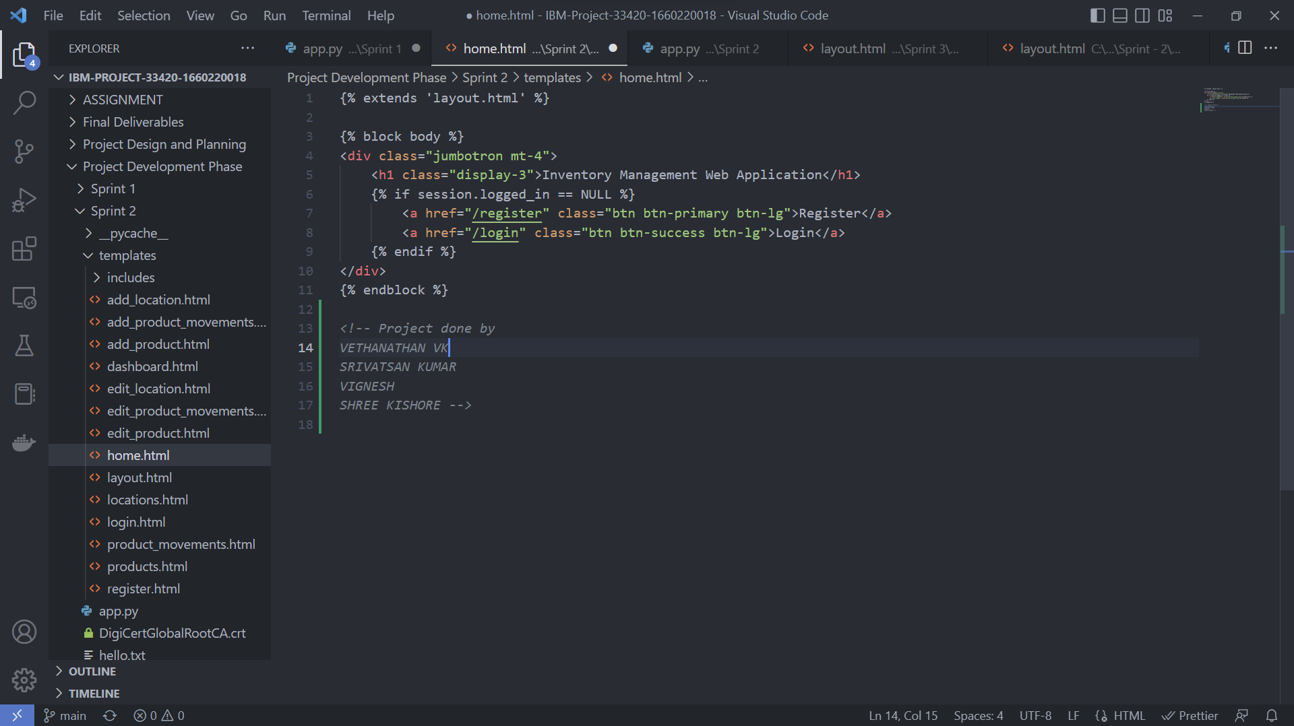

## **SAMPLE FRONTEND**

## **HOME PAGE :**

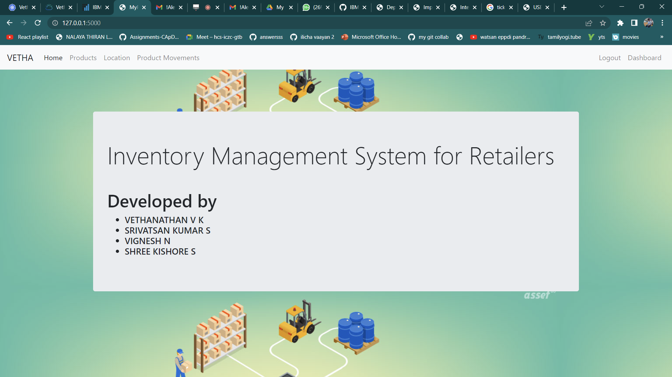

## **LOGIN PAGE:**

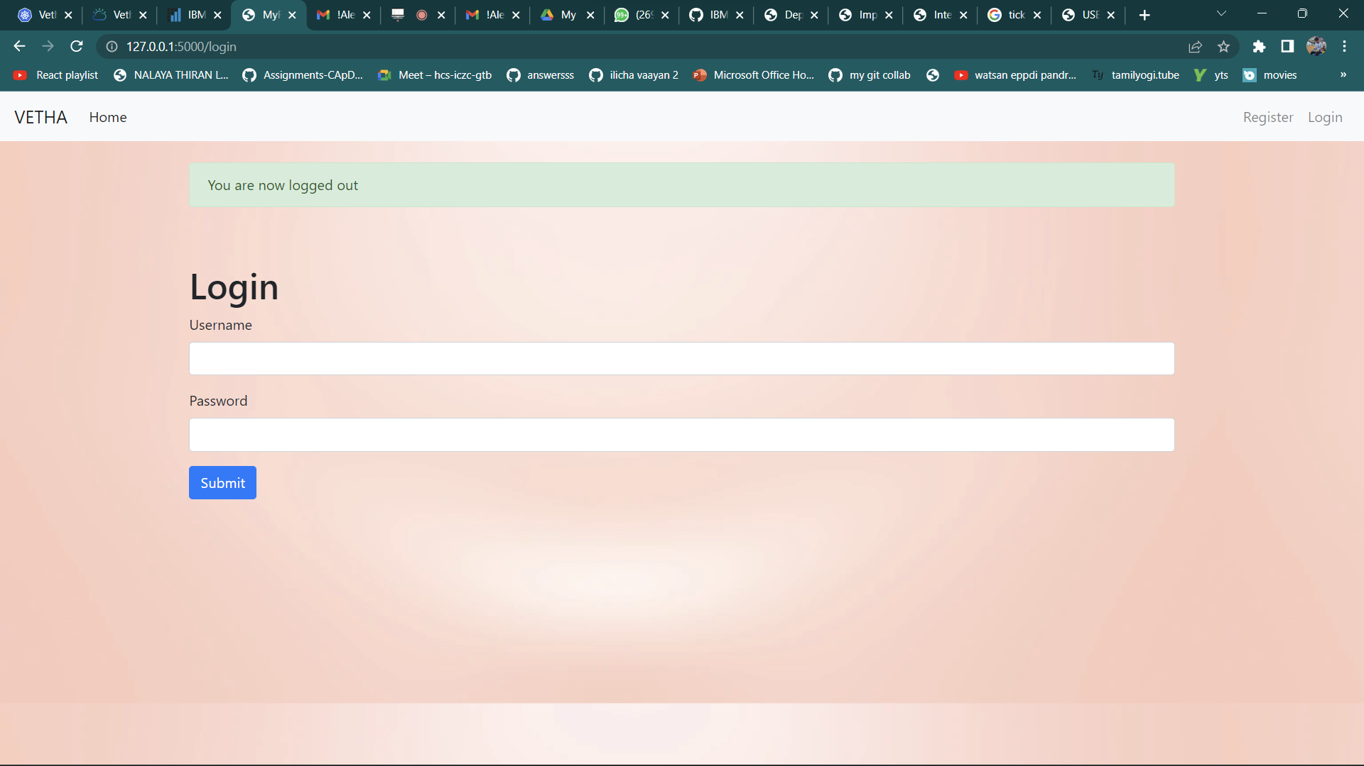

## **SIGNUP PAGE:**

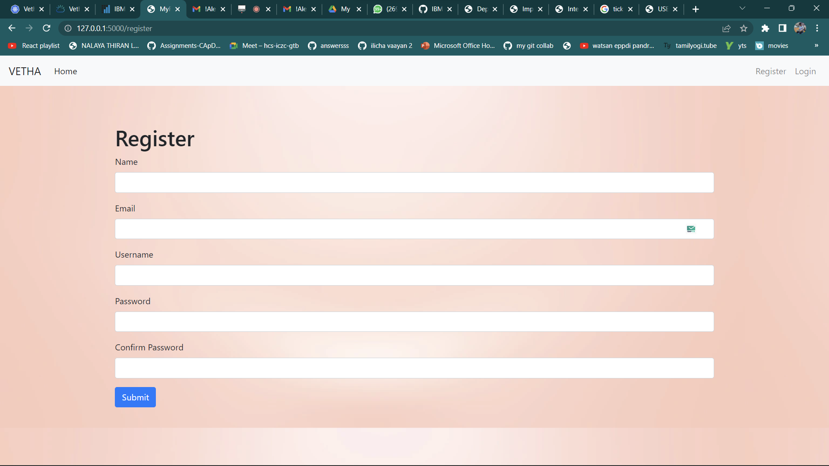

## **Products page:**

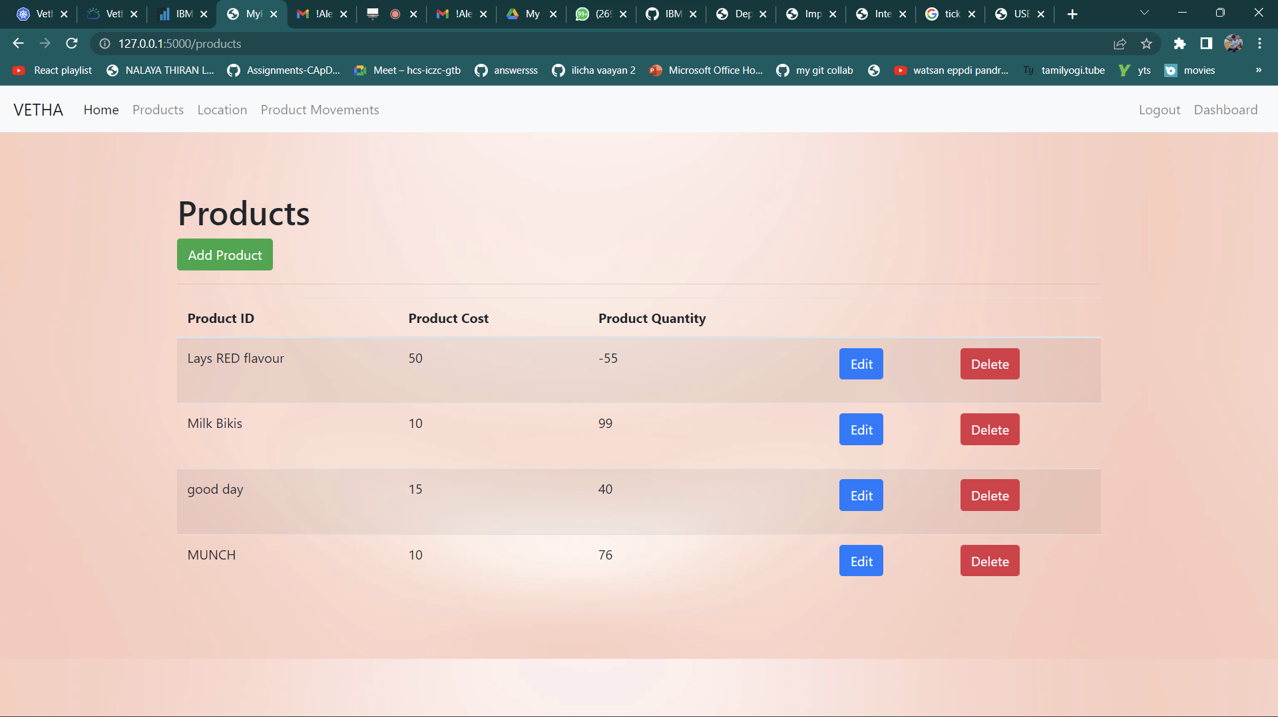

## **Location page:**

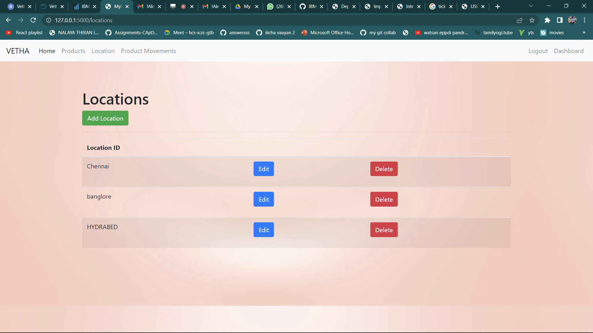

## **Product movements:**

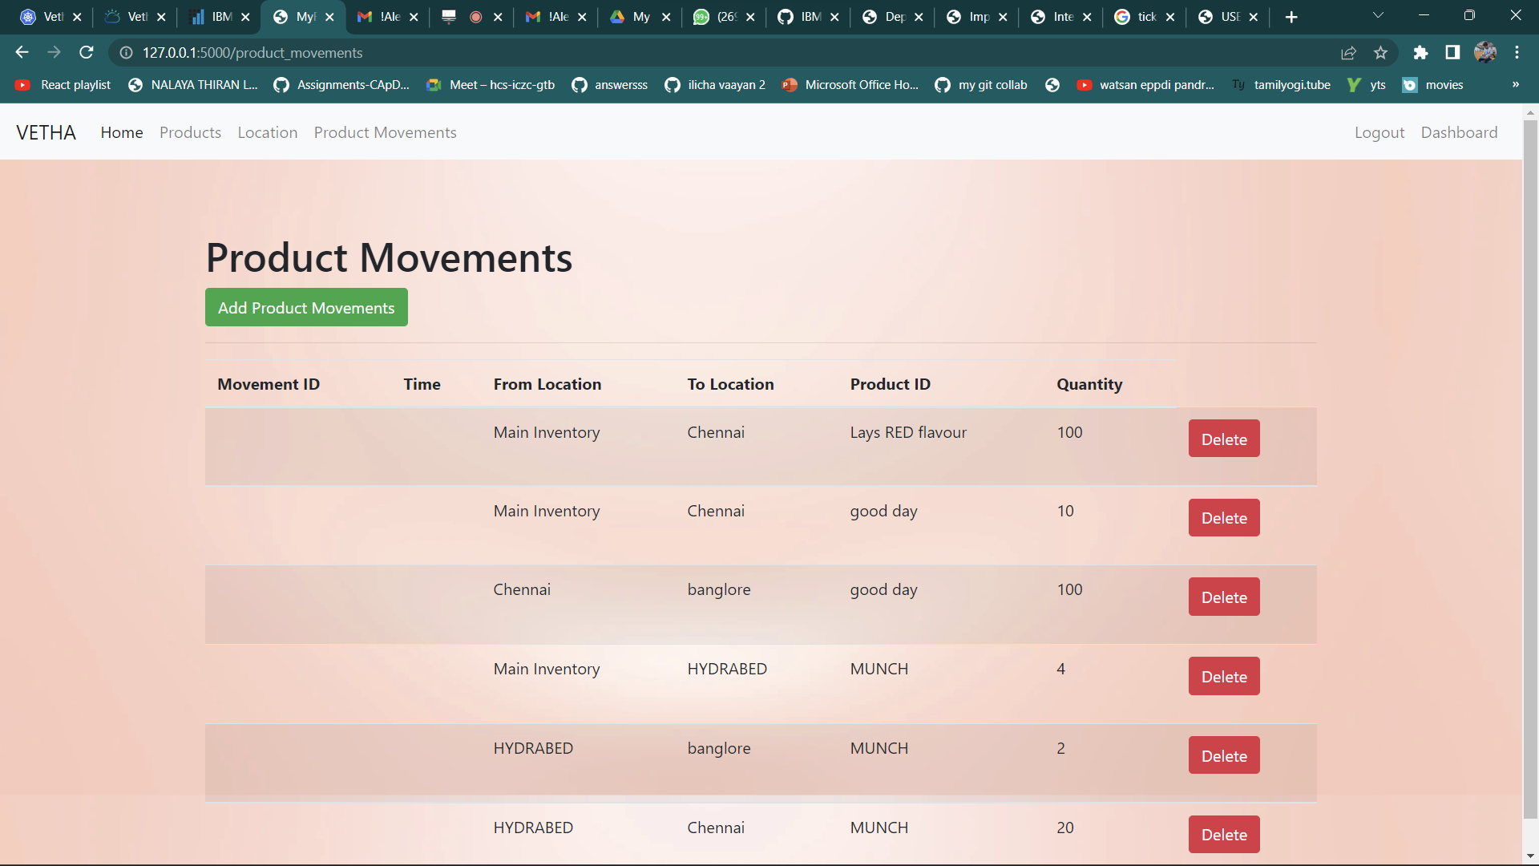

## **Dashboard page:**

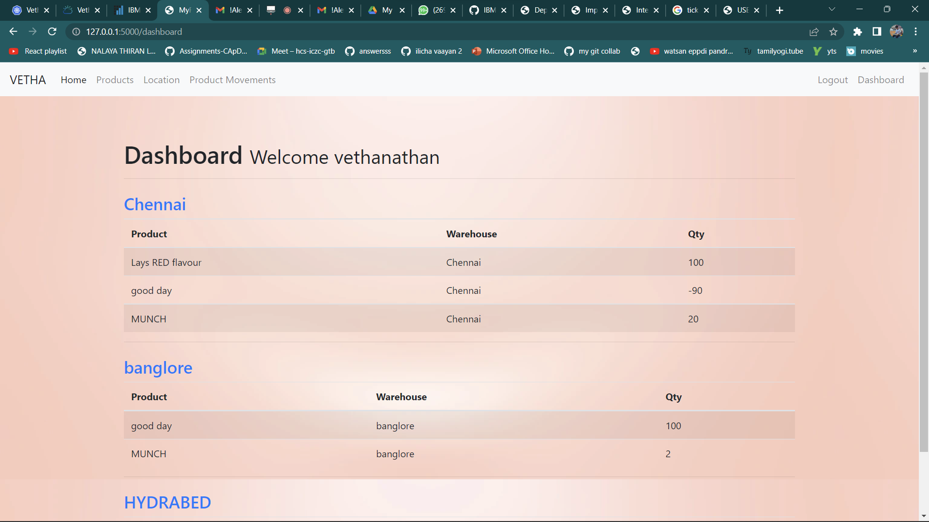

## **Sprint 3:**

- IBM Cloud Integration + Integration of SendGrid: IBM Cloud Integration: 5 tables created for our project,

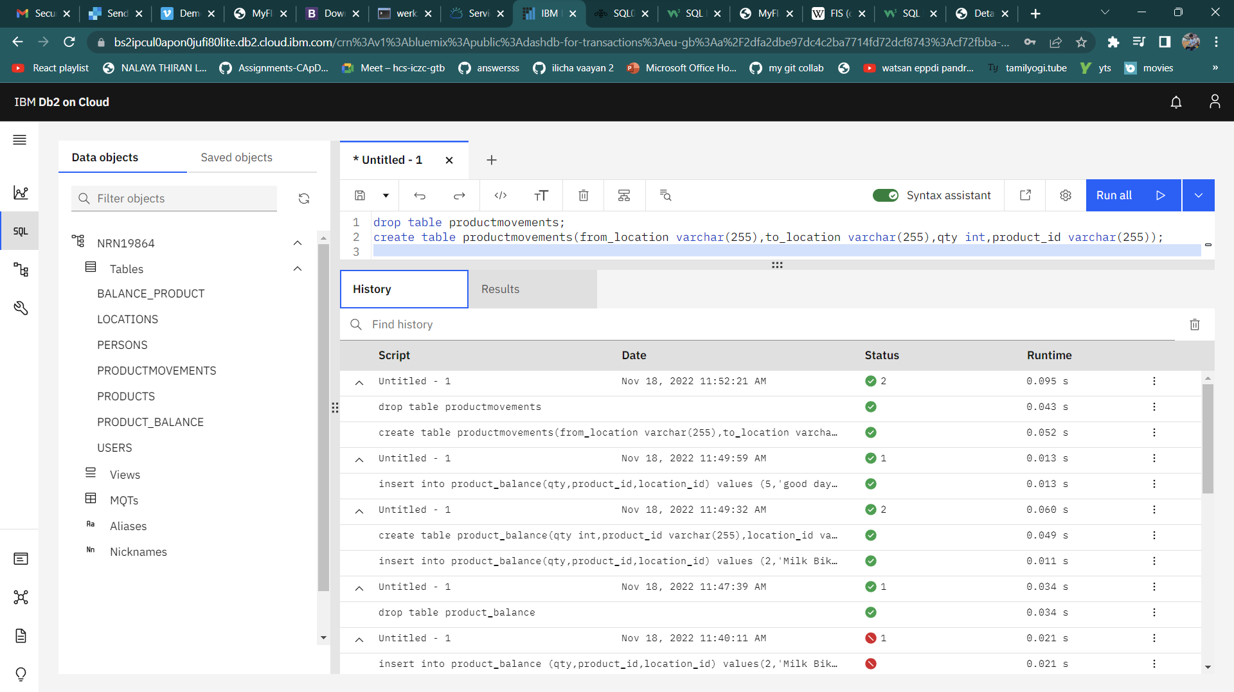

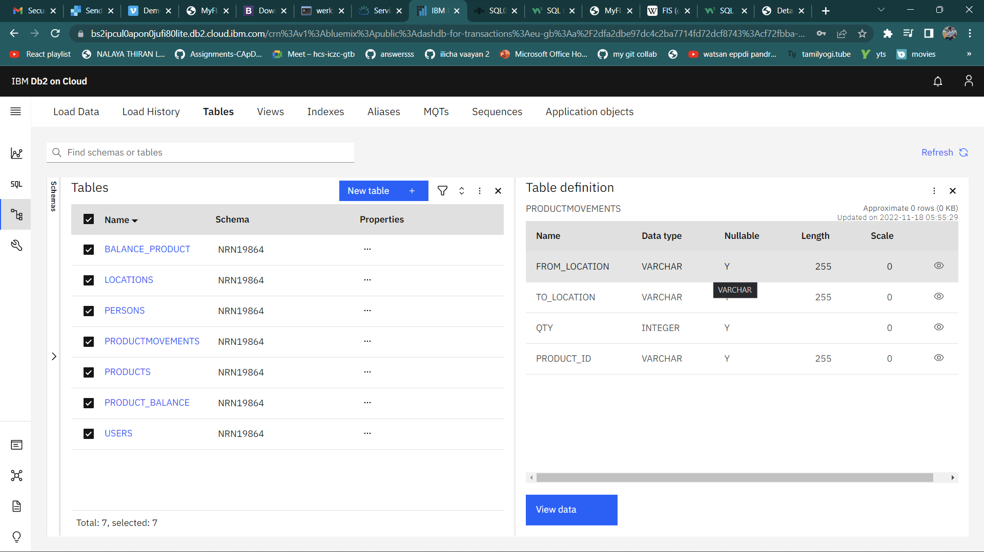

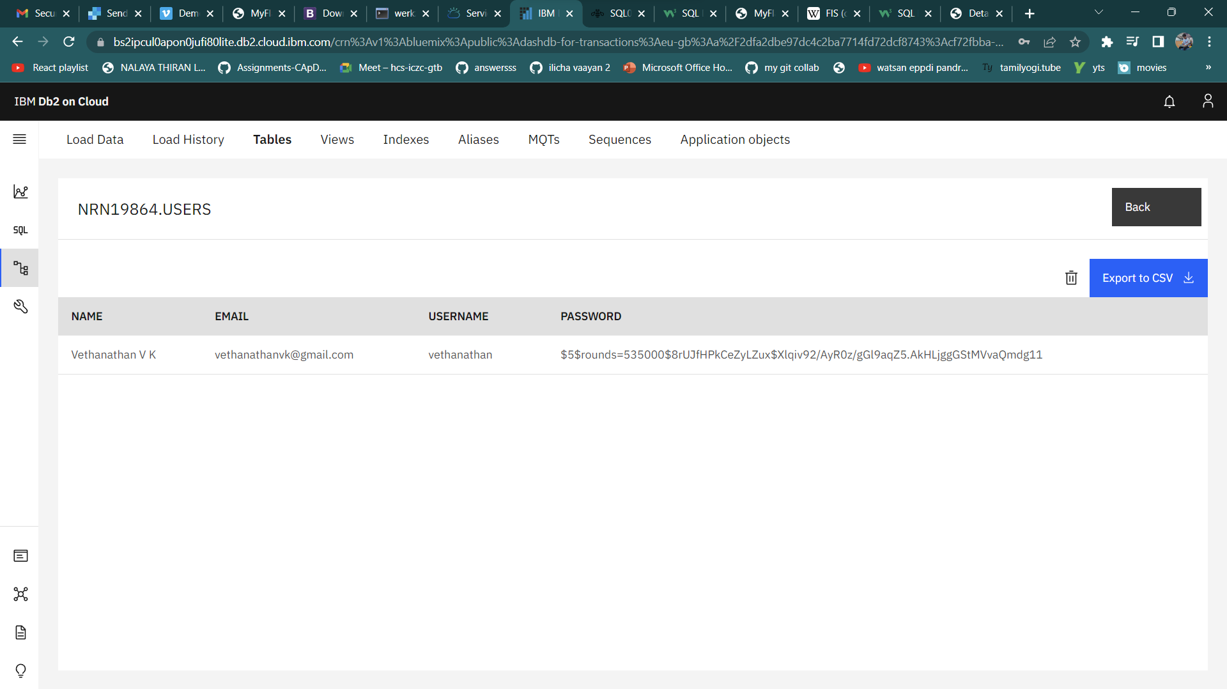

## **Sprint 4:**

Deployment

